GUITAR HERO® METALLICA®

Reviewer’s Guide

Contents

Introduction 3
Playing Guitar Hero Metallica 5
Backstage and More 9
Guitar Hero Metallica Song List 10
Cheats 12

INTRODUCTION

Get ready for some serious whiplash as Guitar Hero® presents their loudest offering to date – Guitar Hero® Metallica®. Join one of the greatest bands of all time and over 20 other legendary guest acts in a searing set list of relentless head-banging fury. So what are you waiting for? Pick up your controllers, hit the lights and jump in the fire!

Key features:

  - Metallica Overload – A definitive selection of Metallica’s most powerful moments, from their 1983 seminal thrash album, Kill Em’ All, all the way to their critically acclaimed 2008 comeback, Death Magnetic. From smash hits like “One” and “Enter Sandman” to obscure favorites like “Orion” and “Mercyful Fate,” the set list has it all covered!

  - 20+ Guest Acts – More than 20 tracks from legendary artists hand-picked by Metallica, including classic rock (Bob Seger, Lynyrd Skynyrd, Thin Lizzy, Queen), classic Metal (Michael Schenker, Judas Priest, Slayer), modern Metal (Mastodon, System of a Down, The Sword), Alternative Rock (Alice in Chains, Foo Fighters), Sludge Rock (Corrosion of Conformity, Kyuss) and more.

  - Be the band – It doesn’t get any more authentic than having James Hetfield, Lars Ulrich, Kirk Hammett and Robert Trujillo perform their own motion capture animations! From their signature stage lighting to heart-pounding pyrotechnics, the thrill of a Metallica concert comes to life!

  - New Expert+ Drum mode – The new Expert+ mode for drums lets you play just like Lars with frenetic double-bass pedal action! Connect a second pedal and take on the most extreme drumming challenge ever.

  - Tons of fan extras – Filled to the brim with bonuses for diehard fans including rare concert footage, behind-the-scene videos, picture galleries and more. Learn more about your favorite band with Metallifacts. Unlock custom Metallica instruments and gear.

  - Complete World Tour features – All the core features from Guitar Hero World Tour remain intact, including the Recording Studio, Rock Star Creator, GHTunes™, Head to Head, online modes and more. The Recording Studio also includes two special tones: ESP bass model used by Tom Araya and ESP Truckster model used by James Hetfield’s.

Guitar Hero Metallica is the ultimate tribute to one of rock’s most celebrated artists. We hope that you enjoy the game. If you have any questions, comments or requests, please feel free to contact us.

Aaron Grant

310-255-2535

agrant@activision.com

PLAYING GUITAR HERO METALLICA

Instrument Basics

Guitar Hero Metallica supports all the instruments from Guitar Hero World Tour. All previous models of Guitar Hero guitar controllers will also work with the game. For other compatability information, visit http://cdn.guitarhero.com/ghhub/GHWT_compatibility.pdf. If this is your first time using World Tour instruments, take a moment to review some of the basic features:

Guitar – The new Guitar Hero World Tour guitar controller has added a Slide Bar to the neck. During a song, Slide Bar sections will appear as transparent notes connected by lines (usually during solo sections). These notes can be played with the Slide Bar or with regular fret buttons – it’s up to you. If you are using a controller without a Slide Bar, these sections will appear as regular notes. Star Power activation – Tilt the guitar or press the new Star Power button.

Bass – The bass parts are played using the same controller as the guitar. A new “open note” has been added to the note charts. The open note symbol appears as a horizontal bar across the note chart highway (much like the bass pedal note for drums). To play an open note, simply play the Strum Bar without holding down a fret button. Star Power activation – same as Guitar.

Vocals – You must have a regular controller inserted into the console in order for the game to recognize the USB microphone. The controller is then used to navigate through the menus. Like the drum controller, there are free form “Vocal Fill” moments where the singer can improvise freely. Star Power activation – Tap the head of the microphone or press any of the face buttons on the regular controller (e.g. A, B, X, Y on the Xbox 360).

Drums – The drum controller pads match the colors that appear on the note highway. The horizontal bar represents the bass drum note. Note that there are free form “Drum Fill” moments when the player is free to play anything. It is recommended that you “rest” your foot on the bass pedal when you’re not playing a note in order to avoid straining your foot muscles. Star Power activation – Hit the two cymbals (Yellow and Orange) simultaneously.
New Drum features for Guitar Hero Metallica


Expert+ difficulty – Play double bass drums like Lars! Add a second bass drum pedal and take on the toughest Guitar Hero challenge yet! Expert+ songs are marked with skull and crossbones.

“Drum Over” mode – Play any drum pattern over any song without getting penalized in free-form “Drum Over” mode. See the Cheats section.

QUICKPLAY MODE

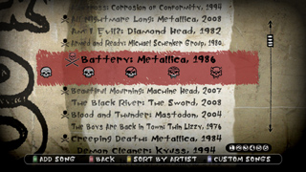
All the songs in the set list come unlocked by default in Quickplay mode in Guitar Hero Metallica. You no longer have to beat the Career mode to play your favorite songs in either Single or Band mode. However, you will be restricted to just two venues – Backstage and The Forum – if you do not complete a set in the Career mode (venues are randomly generated in Quickplay mode). You can choose up to six songs to create your custom set list.

CAREER MODE
New HUD features

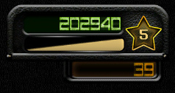

Five Star Meter – You can now keep track of your Star performance as you’re playing the song! On the right side of the screen, nestled between the overall score and note streak counter is the new Five Star Meter. Each time the bar fills up, you will be rewarded with a Star. The counter will max out at Five Stars, indicating that you have successfully achieved a Five Star Performance.

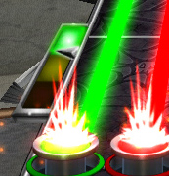

Individual Rock Meters in band mode – Now you can easily tell who’s rockin’ and who’s not when you’re playing in band mode. Each note highway has their own Rock Meter attached to the side. The entire screen will now flash red if the whole band is doing poorly.

The Career mode is the meat of the game where you can unlock various items including instruments, venues, bonus characters and more. You will play as two different bands: Metallica and “Metallica Jr.,” a fictional group vying to land a gig as Metallica’s opening act. As you progress through the story mode, you will play in real-life venues that were pivotal in Metallica’s career.

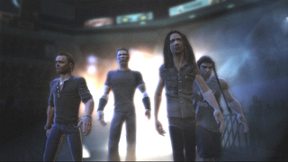

Metallica Opening – After choosing your instrument and difficulty level, the game will play the intro sequence and seamlessly transition into the first song – “For Whom the Bell Tolls” – so get ready! The encore number – “The Unforgiven” – will follow.

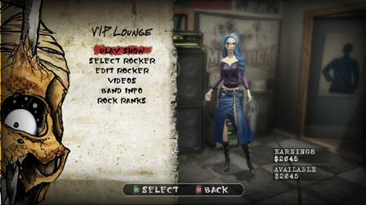
Enter Metallica Jr. – After completing the first two songs at The Forum as Metallica, you will unlock the next venue, Tushino Airfield. You will be taken to the VIP Lounge, where you can select or create your own rocker and fashion your own band name and logo. You can always return here to edit your choices later.

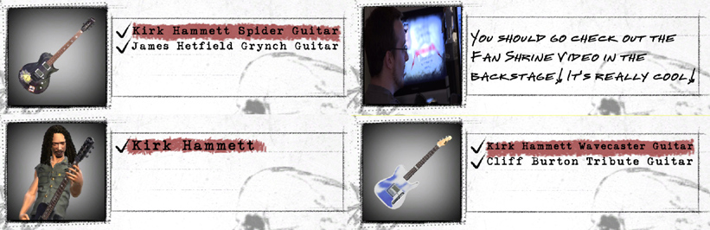
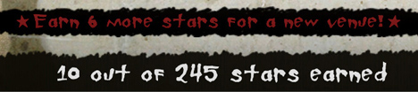
Earn Stars to progress – You will now be able to select any song from the Tushino set list. A new venue is revealed each time you complete the required Star count indicated at the bottom of the set list screen (scroll down). You will need 16 total Stars in order to reveal the next set list – Metallica at Tushino. The order of the set list tracks will be different for each instrument Career (just like in World Tour).
Unlock Goodies –
Earning Stars will also unlock various bonus items in the game, such as instruments, videos, playable characters, etc. For example, in the Guitar career, earning 21 Stars will unlock the Kirk Hammett Spider Guitar and James Hetfield Grynch Guitar. Kirk Hammett is unlocked at 100 Stars in the Guitar career.

Expand on your knowledge with Metallifacts, a special “watch” mode with pop-up style factoids. Learn the story behind the song and how each guest artist relates to the band.
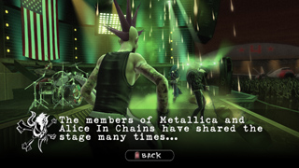

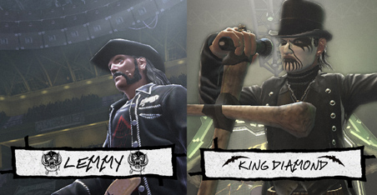

Lemmy and King Diamond (above) – Unlock Lemmy by completing “Ace of Spades” in Career mode. Unlock King Diamond by completing “Evil” in Career mode. All unlocked characters must be purchased in the Select Your Rocker screen ($2,000 each).

BACKSTAGE AND MORE

Guitar Hero Metallica is filled to the brim with Metallica-infused content that goes far beyond the game. It’s the ultimate tribute package for the diehard Metallica fan.

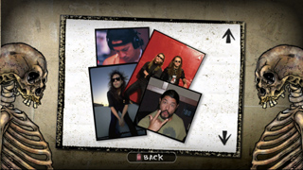
Gallery – Check out old tour photos and concert posters, plus original artwork and lyric sheets!

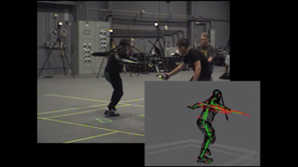
Videos – Get an inside look into Metallica’s contribution to the special motion-capture process and step into the world of a bona fide diehard Metallica fan! Check out official bootleg concert videos from recent Metallica tours, from small clubs to mega arenas.

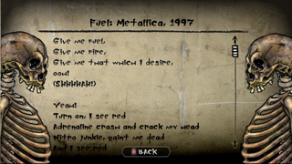
Lyrics/Song Details – Go deeper into a song with full lyrics and publishing details. The entire song is played in this mode so you can follow along.

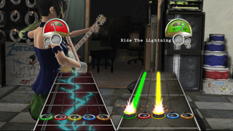
Metallica Power-Ups – The popular Head to Head Battle mode is super-charged with new Metallica Power-Ups, such as “Ride the Lightning” (overload attack), “Trapped Under Ice” (whammy lock) and “Fade to Black” (hide notes).

And it doesn’t end there! Check out the intense, heavier samples in the Recording Studio featuring the ESP bass model used by Tom Araya and ESP Truckster model used by James Hetfield’s. Edit your rocker with new Metallica clothing, accessories and hair! As always, please contact us if you have any questions.

GUITAR HERO METALLICA SONG LIST

Metallica Songs:

Kill ‘Em All (1983):

“Hit the Lights”
“Whiplash”
“Seek and Destroy”

Ride the Lightning (1984):

“Fight Fire with Fire”
“For Whom the Bell Tolls”
“Fade To Black”
“Creeping Death”

Master of Puppets (1986):

“Battery”
“Master of Puppets”
“The Thing That Should Not Be”
“Welcome Home (Sanitarium)”
“Disposable Heroes”
“Orion”

…And Justice for All (1988):

“One”
“Shortest Straw”
“Dyer’s Eve”

Metallica (1991):

“Enter Sandman”
“Sad But True”
“The Unforgiven”
“Wherever I May Roam”
“Nothing Else Matters”

Load (1996):

“King Nothing”

Reload (1997):

“Fuel”
“The Memory Remains”

Garage, Inc. (1998):

“Mercyful Fate”

S&M (1999):

“No Leaf Clover”

St. Anger (2003):

“Frantic”

Death Magnetic (2008):

“All Nightmare Long”

* The PS2 and Wii versions of Guitar Hero Metallica contain three additional tracks: “Broken, Beat & Scarred”, “Cyanide” and “My Apocalypse.”

**The Xbox 360 and PS3 versions of Guitar Hero Metallica support the Metallica “Death Magnetic” full album DLC and allows players to jam to these songs as Metallica for GHIII and GH World Tour

Songs by Guest Acts:

“Ace of Spades” – Motörhead (2008)

“Albatross” – Corrosion of Conformity (1994)

“Am I Evil?” – Diamond Head (1982)

“Armed & Ready” – Michael Schenker Group (1980)

“Beautiful Mourning” – Machine Head (2007)

“The Black River” – The Sword (2008)

“Blood and Thunder” – Mastodon (2004)

“The Boys are Back in Town” – Thin Lizzy (1976)

“Demon Cleaner” – Kyuss (1994)

“Evil” – Mercyful Fate (2008)

“Hell Bent for Leather” – Judas Priest (1978)

“Mommy’s Little Monster – Live” – Social Distortion (1998)

“Mother of Mercy” – Samhain (1986)

“No Excuses” – Alice in Chains (1994)

“Stacked Actors” – Foo Fighters (1999)

“Stone Cold Crazy” – Queen (1974)

“Toxicity” – System of a Down (2001)

“Tuesday’s Gone” – Lynyrd Skynyrd (1973)

“Turn the Page – Live” – Bob Seger (1976)

“War Ensemble” – Slayer (1990)

“War Inside My Head” – Suicidal Tendencies (1990)

CHEATS

Always Drum Fill (“Drum Over” mode)
Red, Red, Red, Blue, Blue, Green, Green, Yellow

Black Highway (All black note highway)
Yellow, Red, Green, Red, Green, Red, Red, Blue

Always Slide
Green, Green, Red, Red, Yellow, Red, Yellow, Blue

Air Instruments
Red, Red, Blue, Yellow, Green, Green, Green, Yellow

Invisible Rocker
Green, Red, Yellow, Yellow, Yellow, Blue, Blue, Green

Performance Mode
Yellow, Yellow, Blue, Red, Blue, Green, Red, Red

Hyperspeed
Green, Blue, Red, Yellow, Yellow, Red, Green, Green

Auto Kick
Yellow, Green, Red, Blue, Blue, Blue, Blue, Red

Gem Color
Blue, Red, Red, Green, Red, Green, Red, Yellow

Flame Color
Green, Red, Green, Blue, Red, Red, Yellow, Blue

Star Color
Red, Red, Yellow, Red, Blue, Red, Red, Blue

Vocal Fireball
Red, Green, Green, Yellow, Blue, Green, Yellow, Green

Extra Line 6 Tones!
Green, Red, Yellow, Blue, Red, Yellow, Blue, Green
*This code does not work on the PS2 and Wii versions.

